TECH-A-THON 2022

PROJECTS INC.

PROGRAM TO FLOWCHART CONVERTER

A PROJECT ABSTRACT

# Submitted by

TEAM No:

PURUSHOTHAMAN.M - 210701199

RAGAVENDAR.K - 210701202

SHARVESH.R - 210701244

SEPTEMBER 2022

1. **PROBLEM STATEMENT**

This project converts the given program statement

or algorithm or code into a flow chart, which will increase the concept clarity towards the given problem to the user.

1. **SOLUTION ( PROJECT DETAILS)**

The planning process is complex. It starts with planning, collecting requirements, and developing of scope. That can go either to project level indicators or a project scorecard, both of which lead to the project plan. That plan, of course, leads to resources, budgets, schedules, etc. Each of those subsets leads to another point in the flow chart, such as the communications or risk plan, which in turn flows into the change control plan and quality management. Eventually, you get to approval, which leads to the executing process, or no approval, sending you back to the beginning.

1. **IMPLEMENTATION**

**What is Flowchart Software?**

Flowchart Software is used to draw diagrams of type flowchart which is made of boxes and arrows. Flowchart Software is used in designing and documenting simple processes or programs. Flowchart Software help to visualize what is going on and helps to understand a process. It is also used to find flaws, bottlenecks, and other less-obvious features within it.

Some of the common flowchart types include Swimlane flowcharts, Data flow diagrams, Influence diagrams, Workflow diagrams, and Process flow diagrams. Flowchart Software aligns everything automatically so you don't have to worry about formatting, rearranging, or reconnecting steps. It also provides themes and high-quality symbols for presentation quality every time.

A flowchart is a formal representation (graphical) of processes, plans, steps, sequences, and activities that need to be carried out in that order to achieve a specific outcome. They represent workflow in simple terms that are easy to comprehend by users. These processes are shown in geometric symbols such as circles, boxes, and diamonds, and arrows represent the relationship between the sequences.

Flowchart software generates such diagrammatic representations automatically; it only needs to be fed code.

**Standard features of flowchart software include:**

·      **Library with flowchart symbols:**Different types of flowcharts require different sets of symbols to represent data. Typically, the software comes with different sets of symbols that you can employ to suit the different purposes of your flowcharts.

·      **Intuitive editor:**Flowchart software is normally easy to use and understand. It comes with a user-friendly interface (this may depend on which editor you are using, but generally, they are formally appealing.)

·      **Pre-defined templates**: The software comes with pre-drawn templates for basic programming flowcharts. All you need to do is enter the data and customize a few more things to suit your particular function.

·      **Automatic connections**: Drawing is easy, and there is no need for any artistic skills. The flowchart software automatically aligns, spaces, and connects your symbols to look neat and professional.

·      **Collaboration**: Flowchart software makes it easy to share the files with other parties, and you can also convert them to other formats such as PDF which can easily be shared or attached to presentations and websites

·      **Frameworks**

A framework in programming is a tool that provides ready-made components or solutions that are customized to speed up development. A framework may include a library but is defined by the principle of inversion of control (IoC).

**3.1TECHNOLOGY STACK**

**Library with flowchart symbols**

PyFlowchart

PyFlowchart is a package to:

write flowcharts in the Python language,

and translate Python source codes into flowcharts.

PyFlowchart produces flowcharts in flowchart.js flowchart DSL, a widely used flow chart textual representation. It's easy to convert these flowcharts' text into a picture via flowchart.js.org , francoislaberge/diagrams , or some markdown editors.

**Intuitive editor**

PyCharm is an extremely popular Python IDE. An Integrated Development Environment or IDE features a code editor and a compiler for writing and compiling programs in one or many programming languages.

Furthermore, an IDE comes with a galore of features that facilitate comprehensive software development. As an IDE allocates different colors to different programming entities, typically known as syntax highlighting, it becomes more accessible to:

Differentiate between various programming entities, such as a class and a function, and spot them.

Look for the wrong keywords.

Read and comprehend the code.

Most IDEs feature an auto-complete feature that produces suggestions when writing code. This makes writing code more efficient, quick, and less prone to errors and typos. Other standard features offered by a modern IDE are:

Project editor window for efficiently managing and organizing files necessary for a program/project.

Inspecting the output of the code written using the output window

Suggestions for resolving errors and warnings

A range of modules and packages readily available in a single place

**Pre-defined templates**

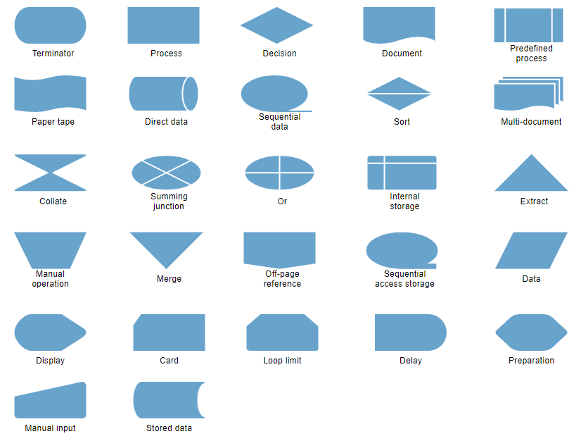

**Automatic connections**

Flowchart.js is a great tool for creating quick, simple flowcharts in a way that keeps you out of a WYSIWYG, and keeps you productive. No more drawing lines, no more determining how to draw a shape, no more deciding relative size, and distance. Flowchart.js makes it easy to prototype new concepts and confirm product flows. Built-in JavaScript, the library is complete with HTML rendering and a standard grammar and syntax for creating your flows.

**Frameworks**

PyQt connects the Qt C++ cross-platform framework with the Python language, it is a GUI module.

Qt is more than a GUI toolkit, which is why it features abstractions of network sockets or threads, along with Unicode, SQL, databases, SVG, OpenGL, XML, an operational web browser, a service system, and a vast array of GUI widgets.

The principle on which a Qt class functions is related to a slot mechanism responsible for offering communication between items to design re-usable software components with ease.

Also, Qt comes with Qt Designer, a tool that acts as a graphical user interface. PyQt can design Python code from Qt Designer while adding new GUI controls when both Qt Designer and Python programming language are used.

**3.2 DESIGN AND ARCHITECTURE**

A flowchart, a type of diagram representing an algorithm, workflow, process, etc., works by showing the steps using shapes, such as boxes of various kinds, and putting them in order by connecting them with arrows of different lengths and shapes too. Such diagrammatic representation named “flowchart” can help illustrate a solution model to some given problem and solve it within a shorter period, rather than trying to explain something using only text, but no drawings at all. Flowcharts are very useful illustrations and they are commonly used in analyzing, designing, documenting, and managing fields of business activity.

1. **CONCLUSION**

This repository contains algorithms and flowcharts for diverse projects to help people learning to program understand the logic and apply their knowledge using any programming language.